Development fill in the blank notes
The development continues…
- Infancy _________________
    - is characterized by : Rapid ____________ development
    - Fast ________________. Development of _________________ system
    - ___________ by 1 yr, ____________by 2 yrs.
Early childhood ____________
    - Is characterized by: Rapid ________________, Development of __________________ skills (colouring),
    - ______________(learning to socialize with peers),
Childhood _____________
    - Is characterized by: Slower ________________, Increased _____________ and ____________________.
    - (kids learn to jump-rope by 5 and ride a bike by 7)

Adolescence __________________

- Adolescence is from the Latin word that means _________________
- It wasn’t used as a life stage until __________.
- Before that you were considered an ______________________.
Now we recognize it as an important stage of development.
It is characterized by:
_____________: the development of _______________ organs. _____________characteristics.
______________: a time of discovering who you are.
End of _____________.
Girls last growth spurt ______________. Boys last growth spurt _______________
Continued ___________development for girls until _________, for boys until ________.

Adulthood _______________
__________ stage of human development
__________: Productive and engage in society
____________ and have families
_____________ for women stops at menopause around the ______________
Men can reproduce until ______________.

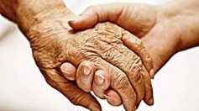
Old age 70 -………..

- For___________ it begins at ________ for ___________ it begins at _________ .
- This is a time when due to the wear and tear of life ___________________________. You have a __________________ of activities.
- You get _______________ in your eyes or you need a _______________, your _______ don’t work and you need a ____________.
- Some people live a very______________ old age.
- The __________ you live, the _______________ your life expectancy.
- Right now in Canada the average _________________ is ____ for men and _____ for women.
- Financial advisers will tell you to plan to live _________________.

Match the life stage to each picture
a.____________ b.___________ c.__________ d. _____________ e.______________
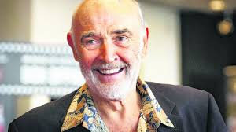
f.___________ g.___________ h.__________ i______________ j.___________
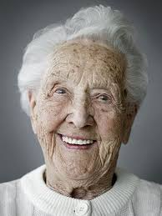
k.______________ l.___________ m. ___________ n.___________ o.________
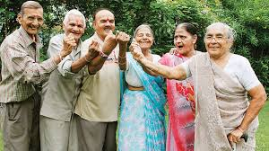
p. ____________ q. ____________ r.________________ s. Camilla Gabello ________
t.Chance the Rapper u. Alexis Lefreniere v. Ariana Grande w. Billie Eilish
_______________ _________________ _______________ _________________

