Fill in the blanks stages of pregnancy
  - _________________ floats in the _________________ and divides until it becomes a ball of _________ cells and embeds in the uterine wall. (3-5 days)
Embryo
  - Once embedded in the _______________ it is called the ______________
  - Cells continue to divide and start to ___________________
  - Until all the ___________________ are formed. (Up to 8 weeks of pregnancy)
Fetus
  - The cell divisions continue and organs develop until about 40 weeks when birth occurs
Attachment
- The fetus attaches to the mother with an _______________________________.
- This is connected to a special organ called the ___________________________.
- The placenta allows the mother and baby’s ____________ to get really _____________
and exchange _____________ and ______________ by ________________ but the two bloods never __________.
- This _____________ both the mother and baby
- The ________________________ is the ___________ where the umbilical cord was attached
Development
- At _________the fetus is attached and has a _________, chest and abdomen _____________ and a ______________
- It’s about the size of an ____________________ 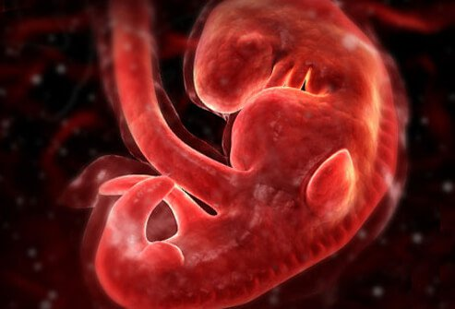
At 8 weeks
- You can see_____________ features, ______________and ________________
- It is 1.1 cm which is the size of a ____________________ 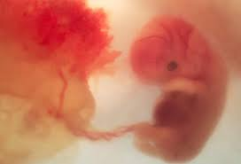
12 weeks
- Now the fetus has a __________________
- It can wiggle its ________________
- Its __________________ organs are developing
- It’s 4.4cm or the size of a_________________
16 weeks
- At this stage the fetus looks like a baby 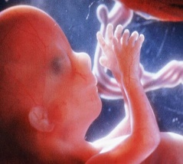
- And it even has ________________________.
- Now it’s about 10 cm which is the size of an _______________ Mom starts having a baby bump.
At 20 weeks
- It can start _______________, _____________ its feet, ___________This is called “quickening”
- Now the fetus is 13cm. The size of a ______________________
At 24 weeks
- The inner ear starts to develop. The baby can __________
- It even gets the _________________
- Now it’s a little more than ½ a kilo, the size of a _____________________
At 28 weeks
- The baby has a good chance to survive if born ________________
- It’s about a kilo the size of a _________________________
At 36 weeks
- 36-40 cm long, 3 kilos ready to be ________, anytime between _______________________
40 weeks Tah Dah!!!! 