STBBI fill in the blank notes
STBBI’s stand’s for _____________________________________________________________________
- These infections are spread by having _________________ sex, _________ contact and sharing _________ (use a __________________!!!)
- and with contact with body fluids like _______________
- (Never share ______________for drugs or needles for _________ or ______________.)
- These infections can be very slow in growing and even asymptomatic. This means you ______________________________________________________________.
- Some are caused by ________________. These can be treated with ________________. Many of these diseases are rapidly becoming antibiotic__________________________.
- Some are caused by ____________________ and can be treated by ____________ medication. Topical means ____________________________________________
- Some are caused by ___________ and can be treated by ___________________ meds
- Some are caused by _______________________ and they _______________ be cured. Some can be _______________________with vaccines.
Bacterial: The best way to treat STBBI’s is __________________…..Use_________
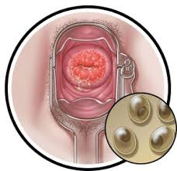
Chlamydia: common in both men and women, often ____________________, causes ___________________, is treatable.

Gonorrhea: common in young adults and teens, _________________________, can cause infertility, ___________ and __________ and very dangerous for ____________. Can cause them ________________________. Treatable. 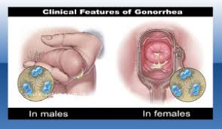
Syphilis: common in women and men between ___________________.
Can be ________________ but is rapidly becoming ________________ to antibiotics. Very _____________ if left untreated.
- Causes lesions in __________,________________, ________ and blood vessels can be passed to ___________ cause _____________

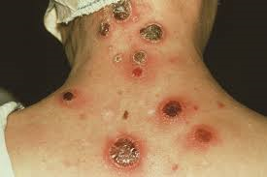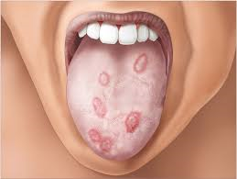
Viral: These infections _________________ easily.
The best form of treatment is________________________.
Use a ____________ and get a ______________________
- HIV/ AIDS: this virus attacks the _____________ system so you can’t fight off other diseases like pneumonia and TB.
- It is eventually _________. The treatment only slows down the process. _____________
- Hepatitis B: causes __________ failure, jaundice, __________.
- This one is somewhat treatable.
- There is a _______________________to protect you against it.
- Herpes: a virus that causes ____________ in both your mouth and ____________ areas. Meds. treat _______________ which last about a week but the ___________________________. You can experience flair ups several times a year.
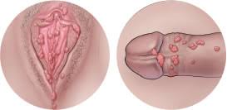
- Human Papilloma Virus (__________): Causes _______________. And leads to cancer of the _________, _________ and ________. Warts can be treated but can ______________. There is a _____________________.

Parasites: the best way to treat these is ____________.
Use ______________.
Pubic lice and scabies: these are tiny _________ ( like little spiders)
Pubic lice live in the _________ of your _______ hair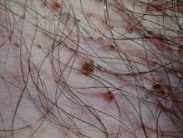 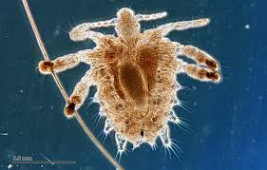
Scabies lives __________________
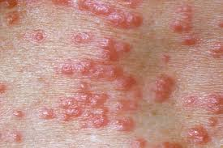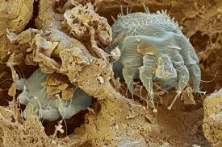
Both cause _________ and _____________
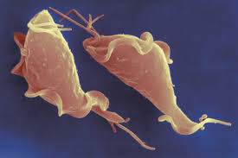
Both are treatable with ___________ containing ________________ medications.
Trichomonas vaginitis:
a __________________(that means a single celled animal) that causes a ___________________________ from the vulva.
- Treatable with medication. Can be spread without sexual contact.

Fungal infections. The best treatment is ______________.
Use _______________
- Yeast infection: causes a __________________________.
- Lots of ___________________ and discomfort.
- Treatable with ________________ and topical cream .
- _________ always ___________________ with sexual contact.

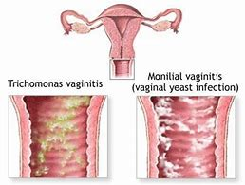

Blue waffle: completely 100% made up. It is not real. Fake news, urban. Don’t believe any of it.
Take away:
- Contraceptive methods: stop you from getting ______________, you may use many ________________________ in your lifetime.
- Condoms: Help ________________________. Be safer use both.
- It’s very important to be in a _____________________________ if you want to get pregnant.

