***The Material World What is __________________???***

* ***Matter is anything that has ______­­­­_______, and takes up _________________ .***
* ***examples:*** 
  + ***bowling balls have lots ________- they are __________ - so they are made of __________***
  + ***you have ___________, and you take up _____________, so you are made ______________.***
  + ***air has only a little ________, but it has some, and takes up ____________________, so air is _______________.***
  + ***any kind of material, ________, __________, or _________ is made of matter.***
* ***The Particle Theory of Matter***
  + ***Matter (of any kind) is made up of extremely ______________________________.***
  + ***These particles are constantly in _____________________.***
  + ***At higher temperatures, these particles move ________________. They would only stop moving at -273 degrees C. This is called absolute zero.***
  + ***These particles are held together by ______________ of __________________, but never actually ______________each other.***
* ***The States (or Phases) of Matter***
  + ***Solids***
    - ***solids have definite __________ and definite _____________***
    - ***the particles in solids are held _________________________________, usually in some geometrical pattern Like a _____________________.***
    - ***the particles in a solid only move by ________________________ - they can't leave their positions***
  + ***Liquids***
    - ***liquids have definite volume, but***

***_______________________________.***

* + - ***the particles in a liquid are held closely together, but are free***

***to _________________________________***

* + - ***the particles have enough ___________ so that they are***

***_______________ in position.***

* + ***Gases***
    - ***Gases have _________________________________________.***
    - ***They will ___________________________to ___________any container that they are in.***
    - ***the particles of a gas are _______________, and are***

***____________________at all***

* + - ***the particles of a gas are flying around very rapidly, at about***

***____________***

* ***Atoms and Molecules***
  + ***____________________are the Particles described in the*** [***Particle Theory of Matter***](http://www.scitec3.esmartstudent.com/what_is_matter.html)
  + 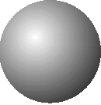***An _______________ is the _________ particle of matter***
  + ***Atoms cannot be ____________into simpler parts by any physical or chemical method***
  + 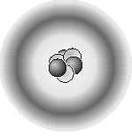***This is what John Dalton thought that an atom looked like:***
  + ***This is what we now think an atom looks like:***
* ***Molecules***
  + ***A Molecule is made up of __________________, combined chemically.***
  + ***By combining together different arrangements of the slightly more than***

***______different kinds of atoms which are known to exist, every kind of substance in***

***the ____________________can be made. (Certain special rules determine which atoms***

***can or cannot be combined together)***

* + ***This is what a model of a water molecule looks like, with ______ oxygen atom, and***
  + ***____ hydrogen atoms:  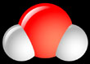***

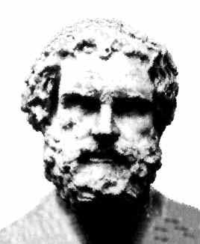 ***A Bit of History*** 

* ***Democritus, a philosopher in ancient _______________, over ________________ years ago,***

***figured out that matter must be made of particles, and he called the smallest of these***

***particles, the atom***

* ***About 1800 year later, an Englishman, John Dalton, came up with more or less the same idea.***
* ***He said that atoms were:***
  + ***extremely _______________________________,***
  + ***_________________________________________,***
  + ***_________________________________________.***
  + ***all the atoms of a ____________________________had the same ________________***
  + ***He also said that different kinds ____________________were made up of atoms of different _____________________.***

***Dalton lived 200 years ago and we know a lot more about atoms now but his ideas are still good and***

***make it easy for us to understand how elements fit together into compounds.***

***Elements and Compounds***

***Elements***

* ***Elements are substances made up of only _____________________.***
* ***Elements, therefore, ___________________________down into any simpler substances by physical or chemical methods.***
* ***Examples of commonly-known elements are _____________, carbon,***

***hydrogen, ___________, copper, ____________, and _____________.***

* ***The four most important elements in the ___________________ are***

***carbon (__), oxygen (__), hydrogen (__), and nitrogen (__)***

* ***The letters in the brackets in the line above are called _____________.***

***These are the correct, official, ___________________ for the names of these elements.***

* ***Here are some more symbols: iron is ____, copper is ____, silver is ____,***

***gold is ____, sodium is ____, and chlorine is ____ .***

* ***The _______letter in any element's symbol is always _______________***
* ***The second letter (if there is one) is ___________________ capitalized.***

***Compounds***

* ***Compounds are substances made up of __________ ______different kinds***

***of elements, combined ___________________________.***

* ***Compounds cannot be broken down by physical methods, but they can be***

***_________________ by ___________________ methods.***

* ***Commonly-known compounds are ____________ (H20),*** 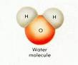
* ***_____________________(NaCl)*** 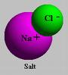

***____________________ (C12H22O11)*** 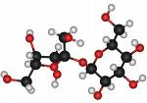

* ***In brackets in the line above, are shown the_____________________ of each of those compounds. A formula is the correct, official abbreviation for the name of a compound, which also shows***

***____________________________________***

* ***_____________________________________________________________***
* ***You can recognize the symbols of the ______________________ that make up those compounds.***
* ***The small, ___________________number after an element's symbol in the***

***formula tells how ________________________of that element there are,***

***in one molecule of that compound.***