**Due: DAY OF DISSECTION! Dissection Date:_______________**

**Virtual Frog Dissection**

**Frog Dissection Pre-lab**

Open the McGraw-Hill Virtual Frog Dissection.

<http://www.mhhe.com/biosci/genbio/virtual_labs_2K8/labs/BL_16/index.html>

***Introduction***

1. Phylum
2. Sub Phylum
3. Class
4. Why are frogs said to have “two lives?”

***External & Internal Anatomy***

1. Dorsal means?
2. Ventral means?
3. Anterior means?
4. Posterior means?
5. Head means?
6. Torso means?
7. Frog lungs are poorly developed. How does this relate to their skin being thin and moist?

1. How does the tympanic membrane work?

1. What 3 systems form the secretions which are released from a frog’s cloaca? __________________________________________________________________________________
2. List 2 ways forelimbs are different than hind limbs

1.

2. _

1. On the virtual frog dissection, what organ was removed first?
2. On the virtual frog dissection, what organ was removed second?
3. On the virtual frog dissection, what organ was removed third?
4. On the virtual frog dissection, what organ was removed fourth?

18. Frogs exchange gasses through the _________________and the ___________________.

19. The glottis leads to the frog’s ______ which connects the mouth to the .

20. Arteries carry blood the heart.

Veins carry blood the heart.

21. connect arteries to veins.

22. A frog’s heart has chambers. Two atrium and ventricle.

23. Urine and solid waste leaves the frog’s body through an opening called the .

24. Muscle tissue is usually grouped into large .

25. A frog’s skeleton is made up of regions.

26. The axial region consists of which bones? _____________________________________________ The appendicular skeleton consists of which bones? ___________________________________ _________________________________________________________________________________

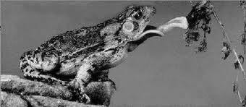27. The frog’s tongue is anchored in the very front – opposite to the orientation and anchoring of humans. Why do you think this is so? __________________________________

***Internal Anatomy***

You will need to visit the second website to identify the location and function of each organ of the frog’s internal anatomy: <http://www.biologycorner.com/bio2/notes-frog.html>(Link is on webpage). *Please color code the parts.*

1. Esophagus (A)

1. Stomach

1. Pancreas

1. Cloaca

1. Lung

1. Ventricle

1. Left atrium

1. Right atrium

1. Vein to heart

1. Artery from heart

1. Liver

1. Gallbladder

1. Small Intestine

1. Large Intestine

1. Spleen



1. Duodenum

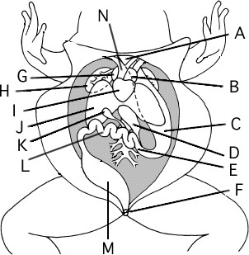

O

Q

R

***External Anatomy***

Draw lines and number the structures of the frog’s mouth.

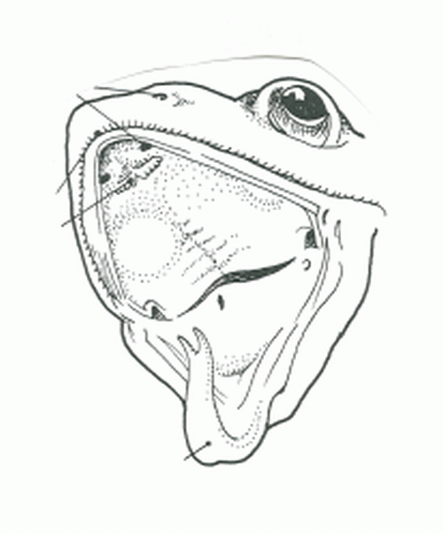

1. Vomerine teeth
2. Maxillary teeth
3. Nostrils
4. Tongue
5. Glottis
6. Esophagus
7. Eustachian tube
8. Nictitating membrane

***Analysis Questions:***

1. Which of the following correctly describes an interaction that occurs between two body systems of a rabbit that helps the rabbit outrun a pursuing coyote?
2. The skeletal system releases additional calcium, and the circulatory system retains more sodium in the blood to provide muscles with ions for contraction.
3. The digestive system increases the rate of digestion, and the excretory system ceases to provide tissues with more nutrients.
4. The respiratory system increases the breathing rate, and the circulatory system increases the blood pressure to provide tissues with more oxygen.
5. The endocrine system released hormones that prepare the immune system to deal with possible injuries.
6. What two human systems work together to provide body cells with a constant supply of oxygen while removing carbon dioxide waste products?
7. Nervous and endocrine
8. Muscular and skeletal
9. Respiratory and circulatory
10. Excretory and integumentary