Work sheet for carbon cycle

- What is the definition of photosynthesis? ____________________________________________________
- What is the definition of respiration?
_____________________________________________________
- What type of organisms can perform photo synthesis? ____________.
- What type of organisms perform respiration ______________&________________
- What is the organelle in the cell that performs photosynthesis? ________________.
- What is the organelle that performs respiration? __________
- What are the inputs of photosynthesis? ___________________

- What are the out puts of photosynthesis? _________________

- What are the inputs of respiration? ______________________

- What are the out puts of respiration? _________________

- Why is it called the carbon cycle? ___________________________________________________

- Write the chemical equations for photosynthesis and respiration. Inputs 0utputs

Photosynthesis ________+ _______+______ ________ + _________
Respiration ________+ ___________ ________+ _______+ _______

Which picture is and animal cell and which picture is a plant cell?
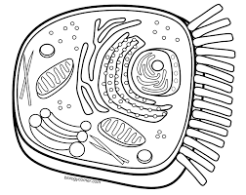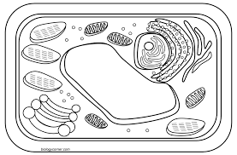
___________________ _____________________
Colour the mitochondria in each cell red.
Colour the chloroplasts in the plant cell green.
In the following diagram fill in the boxes with the following word bank. Some of the words must be uses more than once.
Sun light, energy, respiration, photosynthesis, CO₂, C₆H₁₂O₆, H₂O, O₂

In the following picture place the correct words in the boxes
Cellular Respiration from plants and animals, decomposition, combustion, fossil fuels, photosynthesis
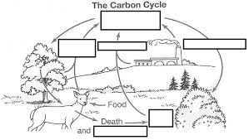

Here is a link to a carrot cake: Bake, eat, respire, and run
https://www.allrecipes.com/recipe/7402/carrot-cake-iii/

